NAAN MUDHALVAN

TITLE : LOGO CREATION

USER NAME : CB03D9275A8AE558C2F4B39295145681

1.Open canva 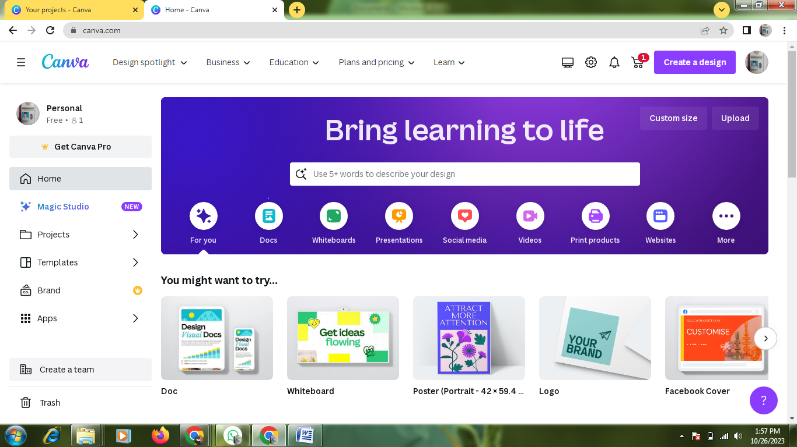

2.select a template 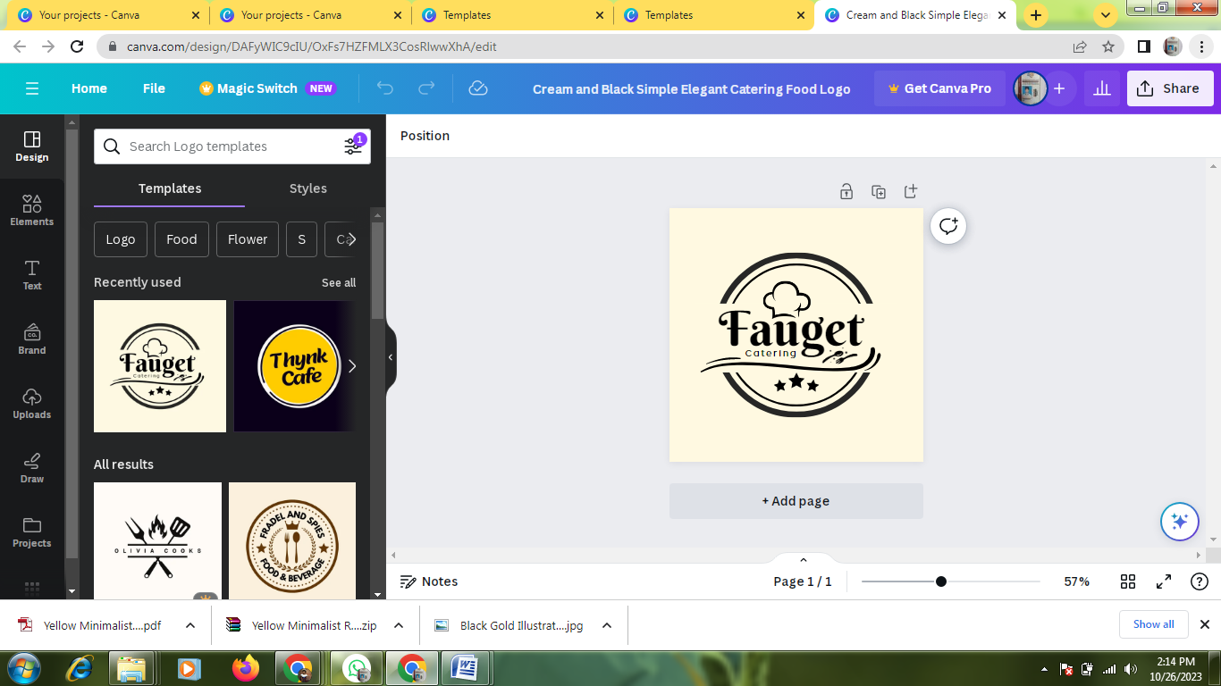

3.Edit a details 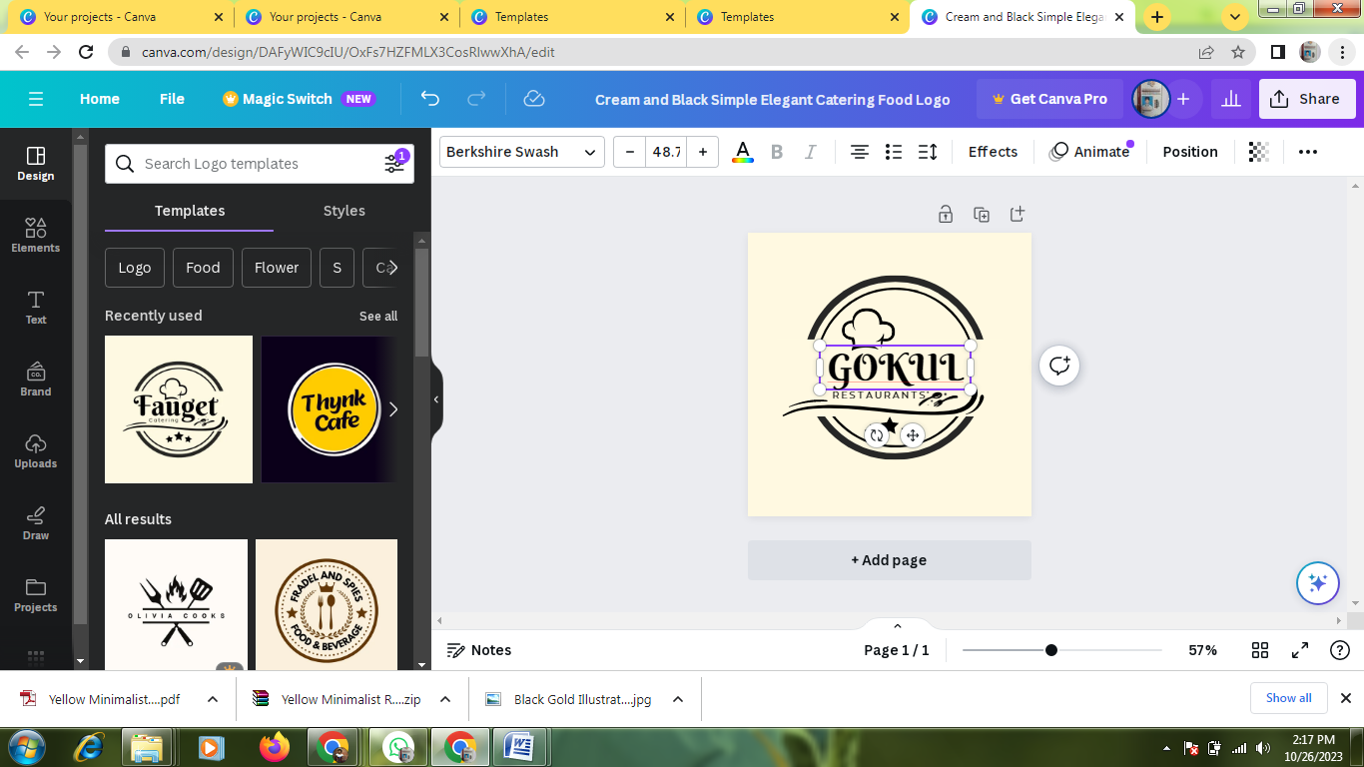

4.Pdf covert 